Development Application – Engagement Template
Application Number/Name | DAP-2026-1
Type | Major Development Consultation

Page sections
What is being proposed? | The proposed development is for a six (6) storey Un-Hosted Short Stay Accommodation (STRA) development at Lots 1 and 2 (No.5a/b) Macrae Road, Applecross 6153.  The application includes the following:  - The development comprises a ground floor car park with one accommodation unit facing the street. 32 parking bays are provided, which comprise 22 “stacked” bays an 10 at grade bays are provided for occupants. The development does not propose any visitor bays.  - The development proposes 21 STRA units, comprising;  - Ten (10) 2 bedroom x 2 bathroom (2x2) apartments  - Ten (10) 3 bedroom x 2 bathroom (2x2) apartments  - Rooftop garden provided for exclusive use of applicants  - Vehicle access to the facility is proposed from 5 Macrae Road, with a new crossover proposed.  - Bins are proposed to be collected from 5 Macrae Road.  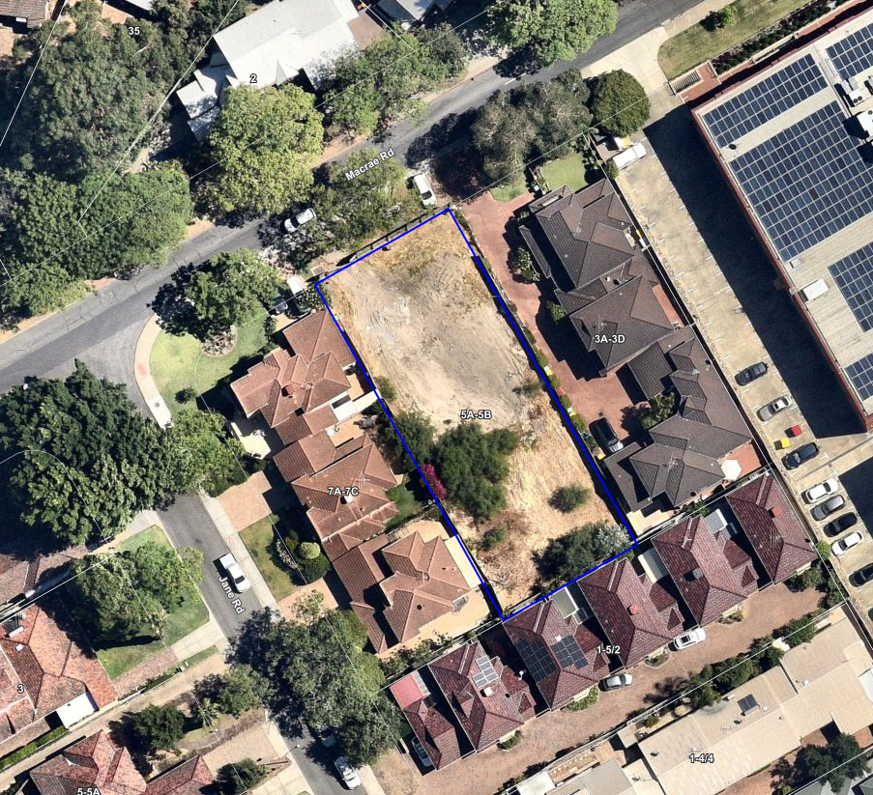  Text for image: This is an aerial image of the subject site, the site is zoned Centre – C2 Local Planning Scheme No.6.
Ways to provide your feedback | Share your feedback by 4.00pm on Friday 29 May 2026.  - Online: by completing our online submission form below  - Mail: Liam Johnson, City of Melville, Civic Centre, 10 Almondbury Road, Booragoon.  The proposed plans are also available to viewed at the Civic Centre, 10 Almondbury Road, Booragoon between 8:30am and 5pm, Monday to Friday, by making an appointment with the assigned officer.
Timeline | - Date received – 20 June 2025  - Open for comment – Friday 1 May 2026  - Closed for comment – Friday 29 May 2026  - RAR due date – 5 September 2025 *DAPs only
FAQs | Remove dot points which are not relevant ↓  Who are we engaging with  The application will be advertised via signs on each street frontage of the subject site and letters sent to property owners and residents within a 200m radius. The City is engaging with the broader public via the City of Melville website.  How is this development assessed by the City?  - The City will assess the proposal against the relevant planning provisions of City of Melville Local Planning Scheme No. 6 and relevant state and local planning policies.  - DAPS: At the completion of the assessment a Responsible Authority Report (RAR) will be prepared by the City’s planning officers and sent to the JDAP to assist it in making a final decision. The City is not the decision maker of this application.  Who is the decision maker?  - The development cost is $16.2 million and the application is to be determined by the Metro Inner South Joint Development Assessment Panel (JDAP).  For more information on Development Assessment Panels please refer to this link. *DAPs only  Why is the City advertising this application?  - Complex Developments: As per the City of Melville’s Local Planning Policy 1.1 – Planning Process and Decision Making, all complex developments are required to be advertised for a period of 28 days to all properties within a 200m radius.  What happens with your comments?  - DAPs: The RAR submitted to the JDAP will provide a summary of the submissions received during the public consultation period. The submissions and the officer response to these will then be considered by the DAP as part of its decision making process.
Contact us | If you require any further information, please contact:  Liam Johnson – Senior Statutory Planner on 9364 0304 or via email spo.spo@melville.wa.gov.au  Please Note: While enquiries can be made via email, to ensure that we capture your information correctly submissions should be made using the above form.
Related information | The following information relates to the subject development application. In addition, Local Planning Policies 1.1 (Planning Processes and Decision Making), 1.6 (Car Parking and Access and 1.21 (Short Term Accommodation) are relevant to this development application and can be found on the following page.

